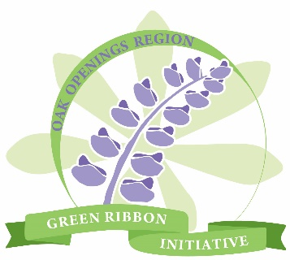

OAK OPENINGS REGION BLUE WEEK
Did You Know? Fact Finding Adventure
Visit 8 of --- participating parks and read the fun fact about a special Oak Openings species. Fill out the form and submit it to oakopenings@tnc.org for a chance to win an Oak Openings t-shirt. 10 winners will be drawn on May 18th.
Date | Park | Species

NAME___________________________________________________________
PHONE NUMBER_________________________________________________________
EMAIL ADDRESS__________________________________________________________
DID YOU HAVE FUN? ________________________________________________

